**Subject Property**

Address: Phum Veal, Sangkat Chreav, Seim Reap City, Seim Reap Provice.

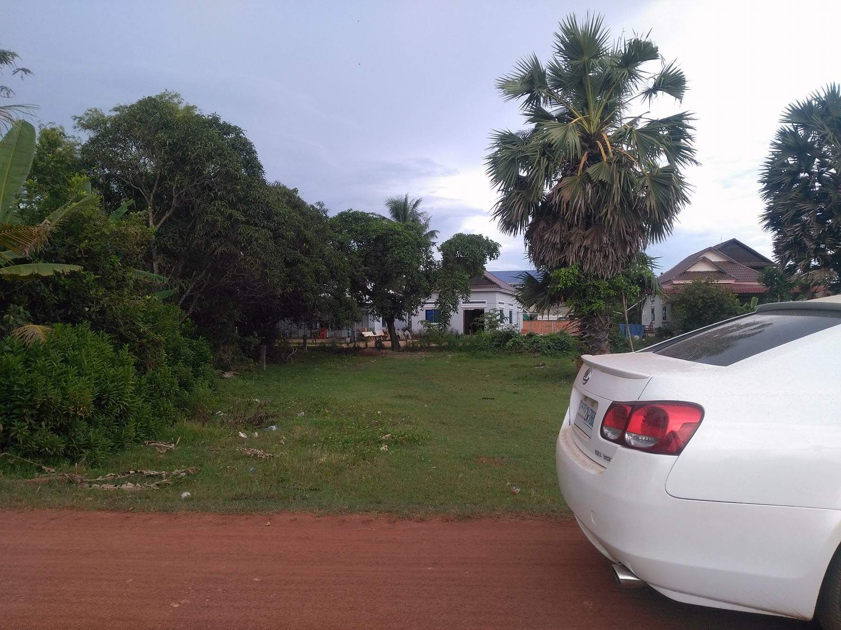Land Size: 652sqm

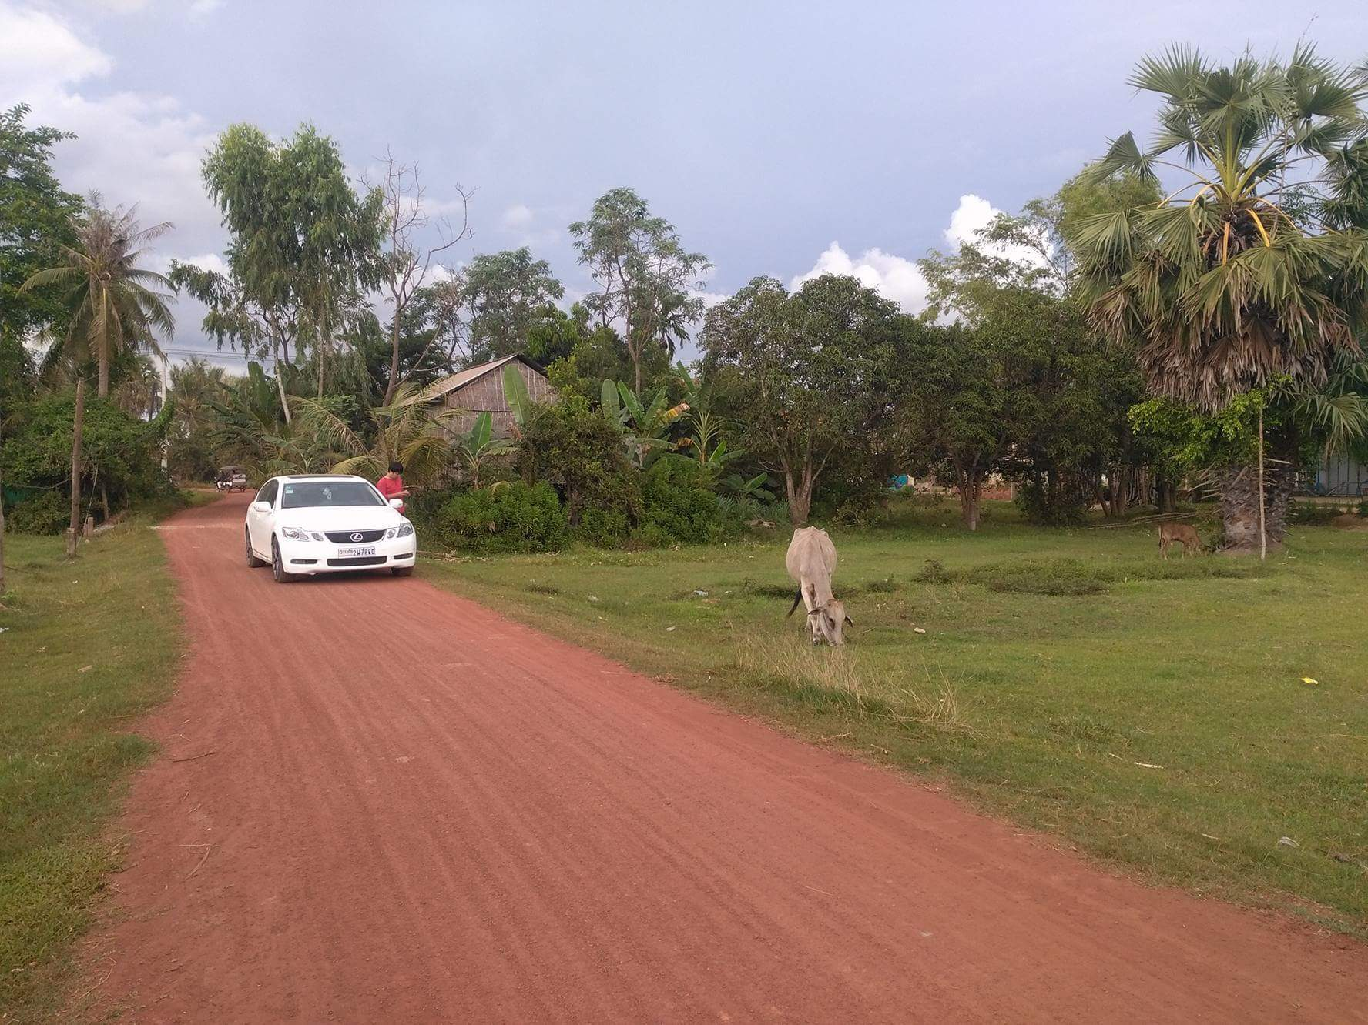

Property 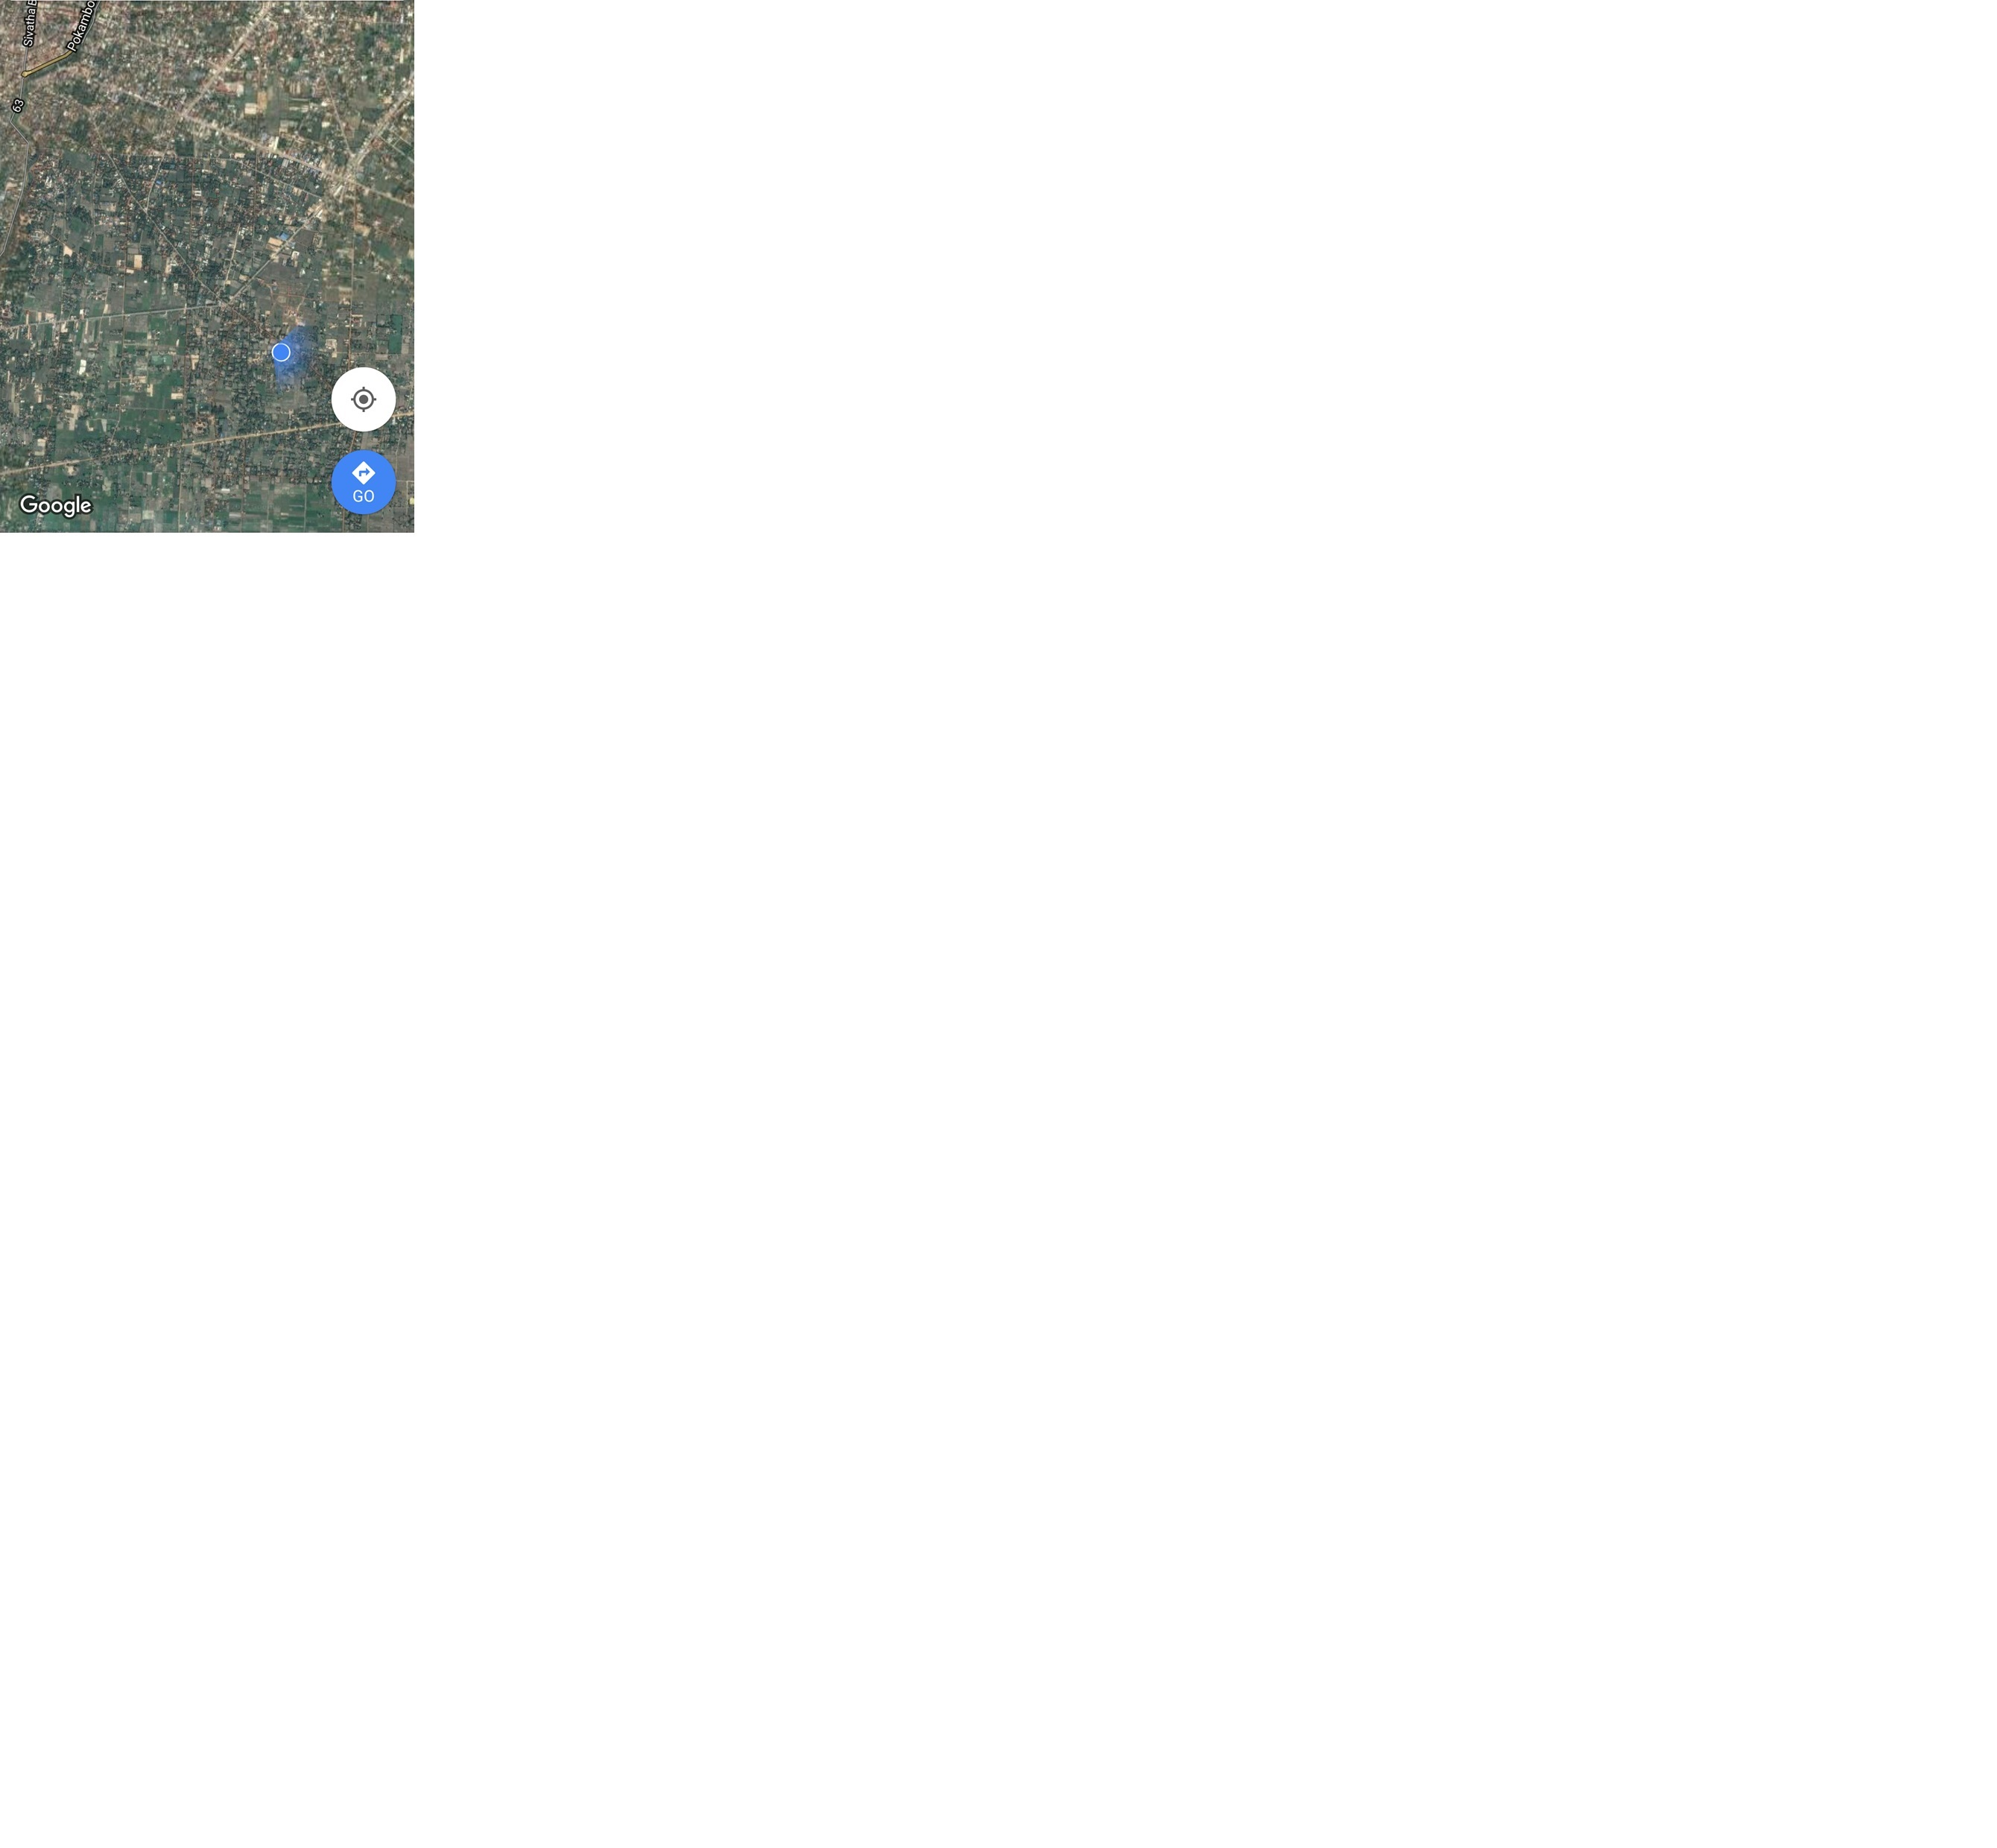

Subject Property